**Project Organization**

* **2.1 Process Model**

The project follows the agile methodology of software development. The model follows an iterative circular progress of the development. It starts with Planning goes into Design then goes to Build stage then Testing stage and then Review. After the first iteration (sprint) is completed the developed part gets launched, and the next iteration gets started.

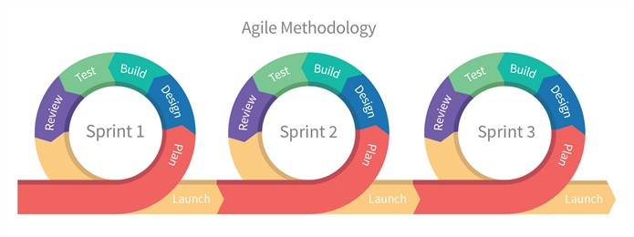

Figure 1. Agile Methodology. © Bikesh Srivastava, [LinkedIn article](https://www.linkedin.com/pulse/what-agile-methodologydisadvantage-waterfall-model-bikesh-srivastava/)

* **2.2 Organizational Structure**

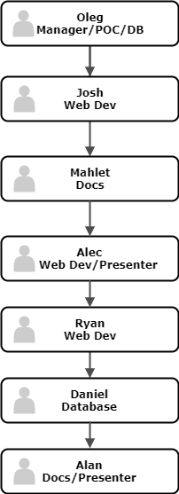

* **2.3 Organizational Interfaces**

Our team will interact with these external entities:

* Client;
* Provider of the payment processor system;
* Heroku: cloud application platform;
* Amazon AWS – cloud hosting;
* Google Domains.